CARNEGIE SHUL CHATTER OMISSION
In preparing the September 6 edition of the Chatter I inadvertently omitted this item that I intended to include. I apologize for this omission.
At the Jewish Federation of Greater Pittsburgh’s Annual Meeting on August 31, the Federation honored the Volunteers of the Year from various synagogues and organiztions, including our very own Burton Dodick. Here is what the Volunteers of the Year pamphlet said about Burt:

CONGREGATION AHAVATH ACHIM
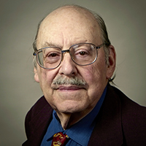Burton Dodick
The Board of Directors of Congregation Ahavath Achim was unanimous in its selection of Burton Dodick as the congregation’s Jewish Federation Volunteer of the Year for 2017. Burt, a regular attendee at Shabbos services for many years, has long taken responsibility for supervising and setting up the weekly Kiddush luncheons that follow the services. Burt does the shopping each week to ensure a bountiful array of lox, bagels, fruit, pastries, and the like for shul members and guests. His selfless devotion to the shul has been unwavering. He has the thanks of all who have been the beneficiaries of his efforts to provide a pleasant conclusion to services. Burton truly deserves Volunteer of the Year recognition.

